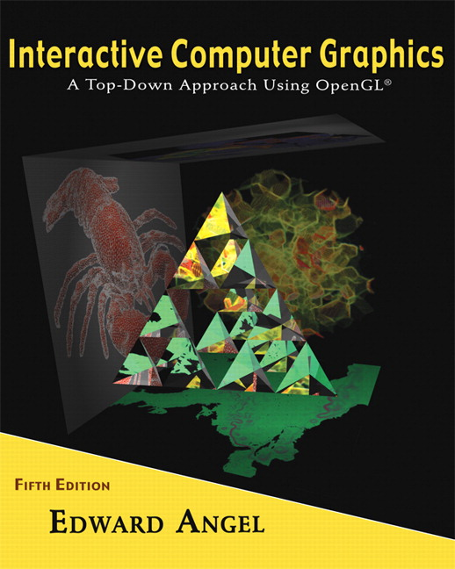 COSC 4370
Name: ____________________ TERMINAL NUMBER ____

Programming Assignment 1 Acceptance Testing:

After you downloaded your zipped project from BB and rebuilt it using the 200 PGH Visual Studio 2010, take screenshots of the output produced, and insert it in this file ……..
1. Adjust the camera so you can get the Front image of BUS (gluLookAt added to display function).
SCREENSHOT Output of your program is:
……..
Copy and Paste your gluLookAt here
……..
2. Adjust the camera so you can get the Back image of BUS (gluLookAt added to display function).
SCREENSHOT Output of your program is:
……..
Copy and Paste your gluLookAt here
……..
3. Adjust the camera so you can get the Side image of BUS (gluLookAt added to display function).
SCREENSHOT Output of your program is:
……..
Copy and Paste your gluLookAt here
……..
4. Adjust the camera so you can get the Isometric image of BUS (gluLookAt added to display function). This means that camera needs to be placed on the line from (0,0,0) to (1,1,1), aiming at the BUS origin (0,0,0) and the up vector is on the y axis (0,1,0).
SCREENSHOT Output of your program is:
……..
Copy and Paste your gluLookAt here
……..

5. Copy and Paste your .c (.cpp) file here:
……..

When done attach this file to “Testing Programming Assignment 1” BB assignment.

